Report on U.S. Disease Indicator Dataset
Official Dataset from: Data.gov
About The Dataset: This dataset was provided by U.S. Department of Health and Human Services. The data is well informed and prepared by Epidemiologists and the national association of Chronic Disease Directors.
The dataset contains at most 115 indicators related to chronic disease data that are important to public health practices in their area.
Our Goal: We aim to predict state-level high-risk diseases prevalence using Chronic disease indicators, the data from the year 2015 – 2022. Also, we want to gain insights from the following questions:
- Can U.S. states be grouped into distinct health profiles based on chronic disease indicators?
- Can we classify states as high-risk vs low risk for chronic disease?
- Our main focus is on two major diseases: Cancer and Cardiovascular diseases that are considered fatal for the human life.
Following is our dataset in a csv format we explored in Excel:
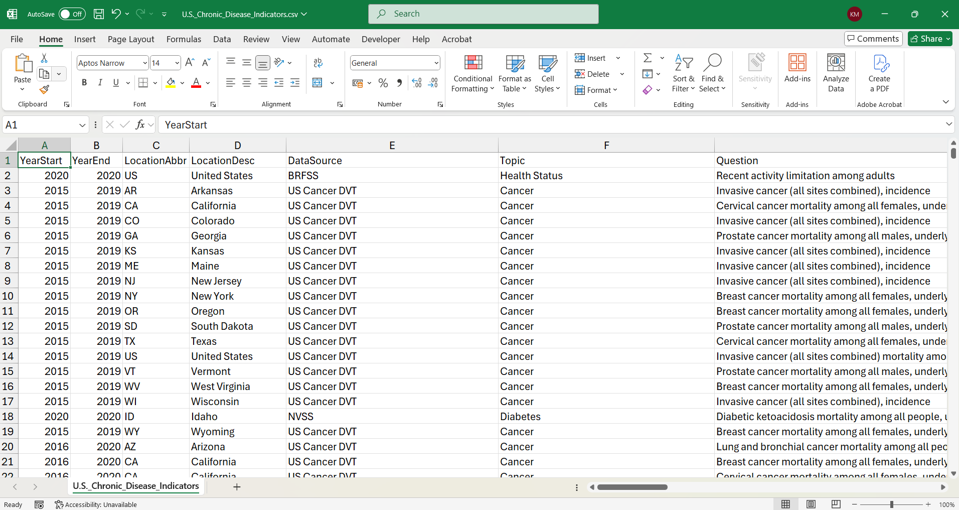
This dataset is massive, it has almost 3 lakhs of records of the patients with their medical history. It has 26 columns or variables. Out of 26 columns 2-3 columns are messy and not useful for our data analysis.
We took this dataset to python for further investigation. We performed data cleaning like removing null’s or unnamed data. Explored the variables and their data types.
This is how we are doing in Python with Jupyter Notebook:
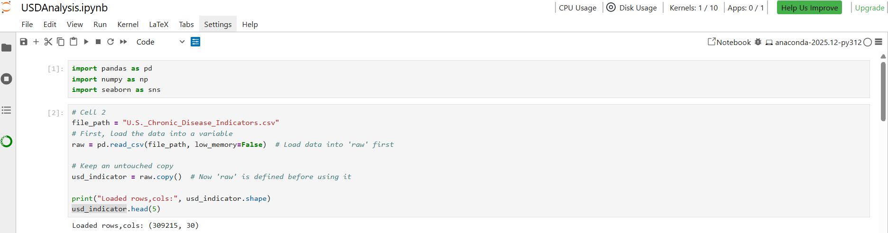
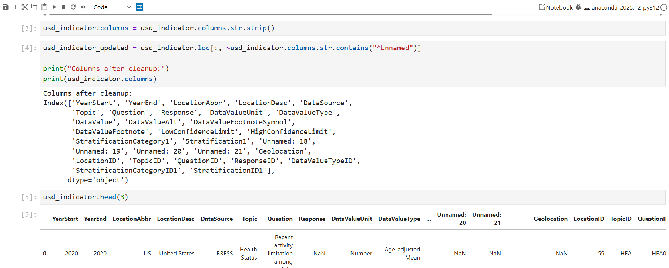

Analysis Part
After removing unnecessary columns, we proceeded for the analysis part. The challenge was to dig into the columns that could help us to explore more about the data.
First, we determined what health topics were frequently encountered in hospitals. We got the following data:
# The code to get the topics:
sorted(usd_analysis["Topic"].unique())
['Alcohol',
'Arthritis',
'Asthma',
'Cancer',
'Cardiovascular Disease',
'Chronic Kidney Disease',
'Chronic Obstructive Pulmonary Disease',
'Cognitive Health and Caregiving',
'Diabetes',
'Disability',
'Health Status',
'Immunization',
'Maternal Health',
'Mental Health',
'Nutrition, Physical Activity, and Weight Status',
'Oral Health',
'Sleep',
'Social Determinants of Health',
'Tobacco']
Following graph represents topics from Highest to Lowest order:
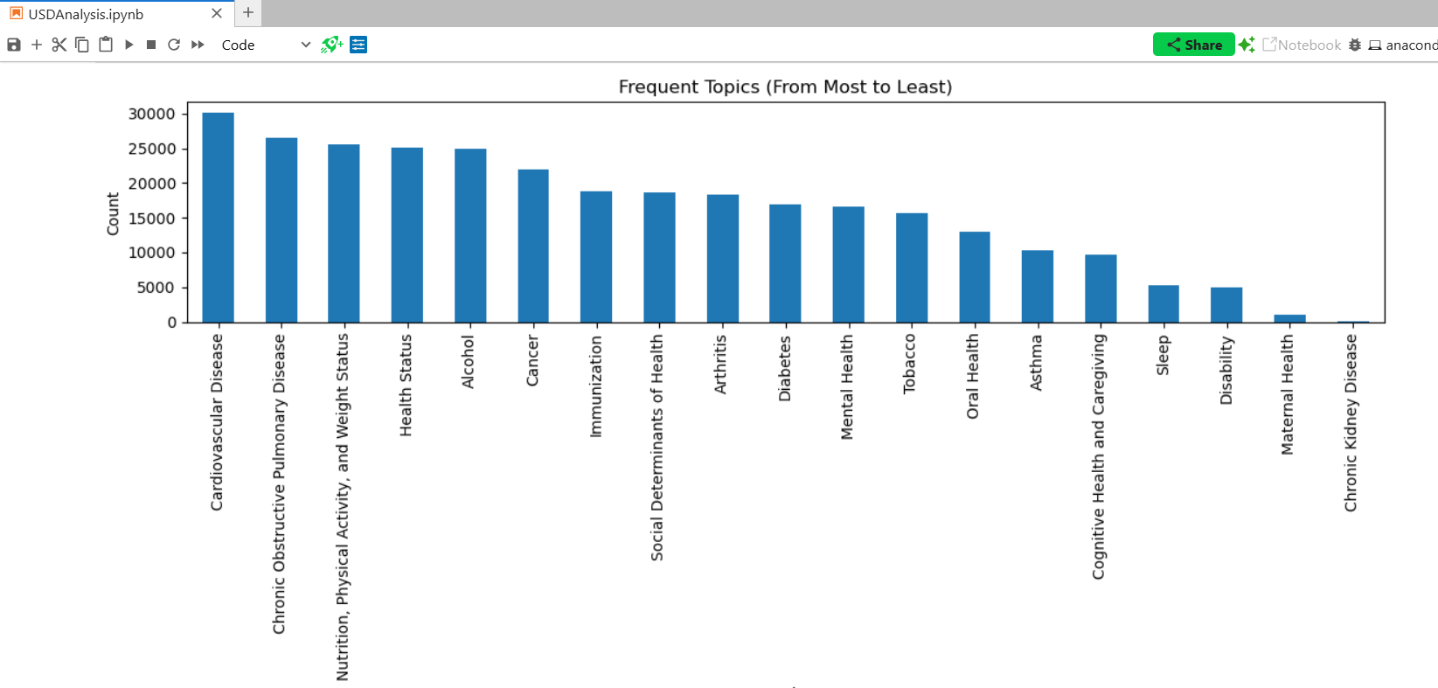

Then our next curiosity lies in knowing what frequent questions hospitals encounter. We selected top 5 topics first.
The following code gets the value for the variable ‘Question’:

This is particular for topic: cardiovascular disease
We selected Questions for the following topics:
- Cardiovascular disease
- Chronic Obstructive Pulmonary
- Nutrition, Physical activity, and Weight status
- Health status
- Cancer
- Diabetes

Clustering Analysis:
We want to analyse which states have the most prevalent and low prevalent diseases. For this wee need to use the clustering algorithm. We used the variable (or column) ‘LocationAbbr’ representing states and their related with health indicators.
# Now computed cluster summary from the original features
num_feats = [c for c in cluster_df.columns if c not in ("LocationDesc", "Cluster")]
cluster_summary = cluster_df.groupby("Cluster")[num_feats].mean()
print(cluster_summary.T)
The following results were obtained:
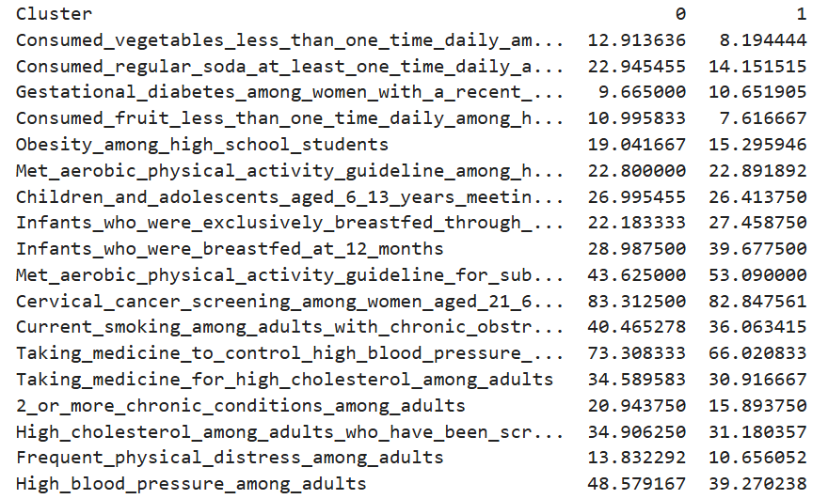

The ‘0’ and ‘1’ column represent clusters here.

Cluster Comparison on Key Health Indicators:
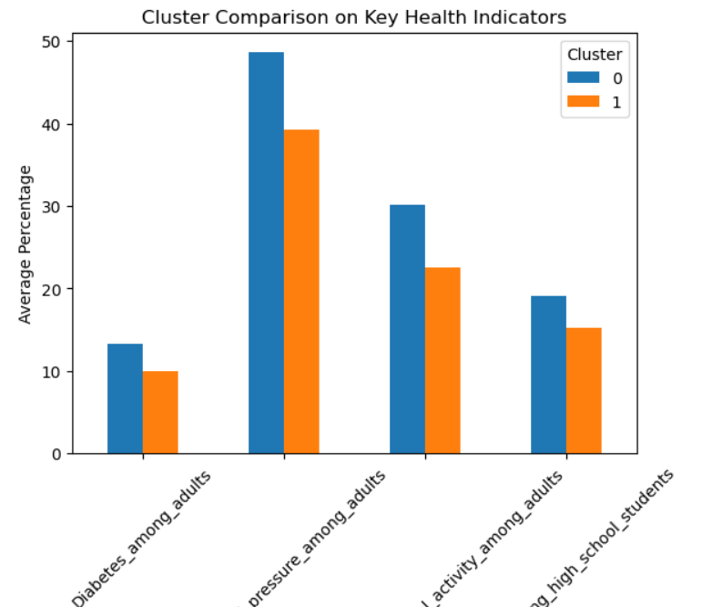

Outcome: Cluster 0 represents a high-risk health profile characterized by higher prevalence of obesity, diabetes, hypertension, and unhealthy behavioural patterns.
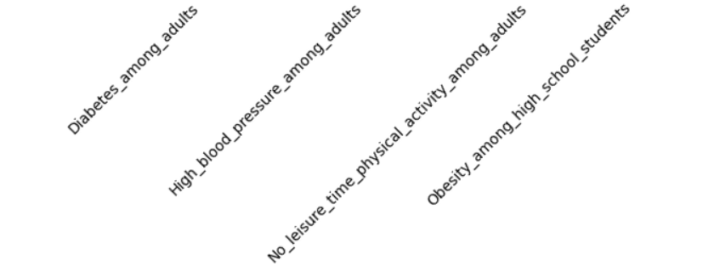

The above 4 problems suggest that governments with the help of doctors should take adequate measurements to tackle such chronic diseases.
The following states grouped into two clusters:
1. High-risk and
2. Low risk illustrates health risks.
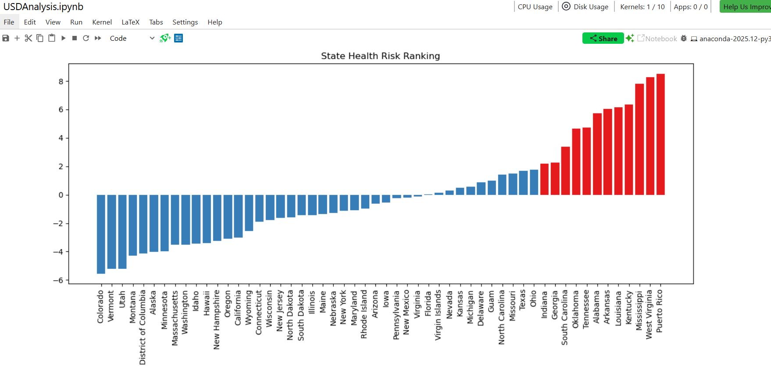

The graph shows, Top 10 high risk states (indicated by red) and Top 10 low risk states (indicated by blue). The high risk states include:
- Mississippi
- West Virginia
- Arkansas
- Louisiana
- Alabama
- Kentucky
- Tennessee
- Oklahoma
- South Carolina
- Puerto Rico
These are widely reported in CDC as High obesity states, High diabetes prevalence and high cardiovascular mortality.
Conclusion: The clustering analysis revealed a clear separation between high-risk and low-risk state health profiles. States such as Mississippi, West Virginia, and Arkansas exhibited the highest chronic disease burden, while states such as Colorado, Vermont, and Utah demonstrated the lowest.

